# Laborator 3

1. Desenat ̧i diagrama cazurilor de utilizare (abreviat ̆a UC) pentru urm ̆atorul

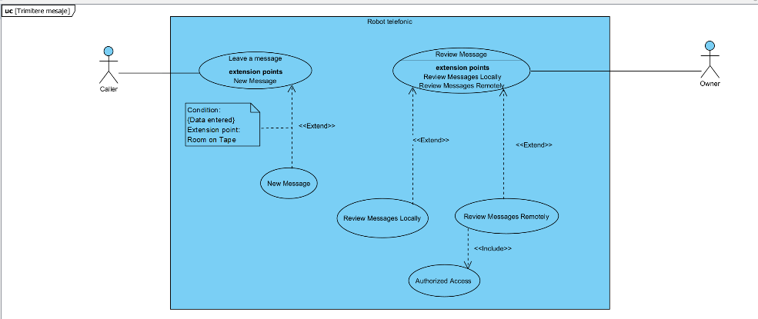robot telefonic.

• UC: Leave a Message

– Actor: Caller

– Pre-Condit ̧ie: Room on Tape

– Post-Condit ̧ie: New Message

• UC: Review Messages

– Actor: Owner

– Cale principal ̆a: Review New

– Cale alternativ ̆a: No New Messages

• UC: Review Messages Locally

– Cale principal ̆a: Review New Messages

– Cale alternativ ̆a: No New Messages

– Extinde: Review Messages

• UC: Review Messages Remotely

– Cale principal ̆a: Review New Messages

– Cale alternativ ̆a: No New Messages

– Extinde: Review Messages

– Include: Authorize Access

UC: Authorize Access

– Cale principala: User Authorized

– Cale alternativa: User Not Authorized